KATIKATI COLLEGE

Level 2 HISTORY
ASSESSMENT BOOKLET

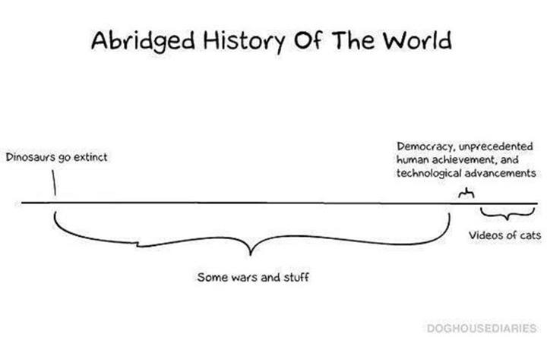

Level 2 HISTORY

Introduction :
The Level 2 History course is a combination of a theme-based approach, achievement objectives and achievement standards
Level 2 History is both broad-sweeping in its look at forces that have shaped our modern world and provides the opportunity for greater depth of study and of historical insight than is required in the Level 1 History course.
The Achievement Objectives for this course will see you gain knowledge, skills, and experience to:
- Understand how historical forces and movements have influenced the causes and consequences of events of significance to New Zealanders.
- Understand how people’s interpretations of events that are of significance to New Zealanders differ.

Topics covered include:

America’s Involvement in Vietnam or Vietnam’s Resistance to America 1955-1975.
Ireland’s ‘Troubles’

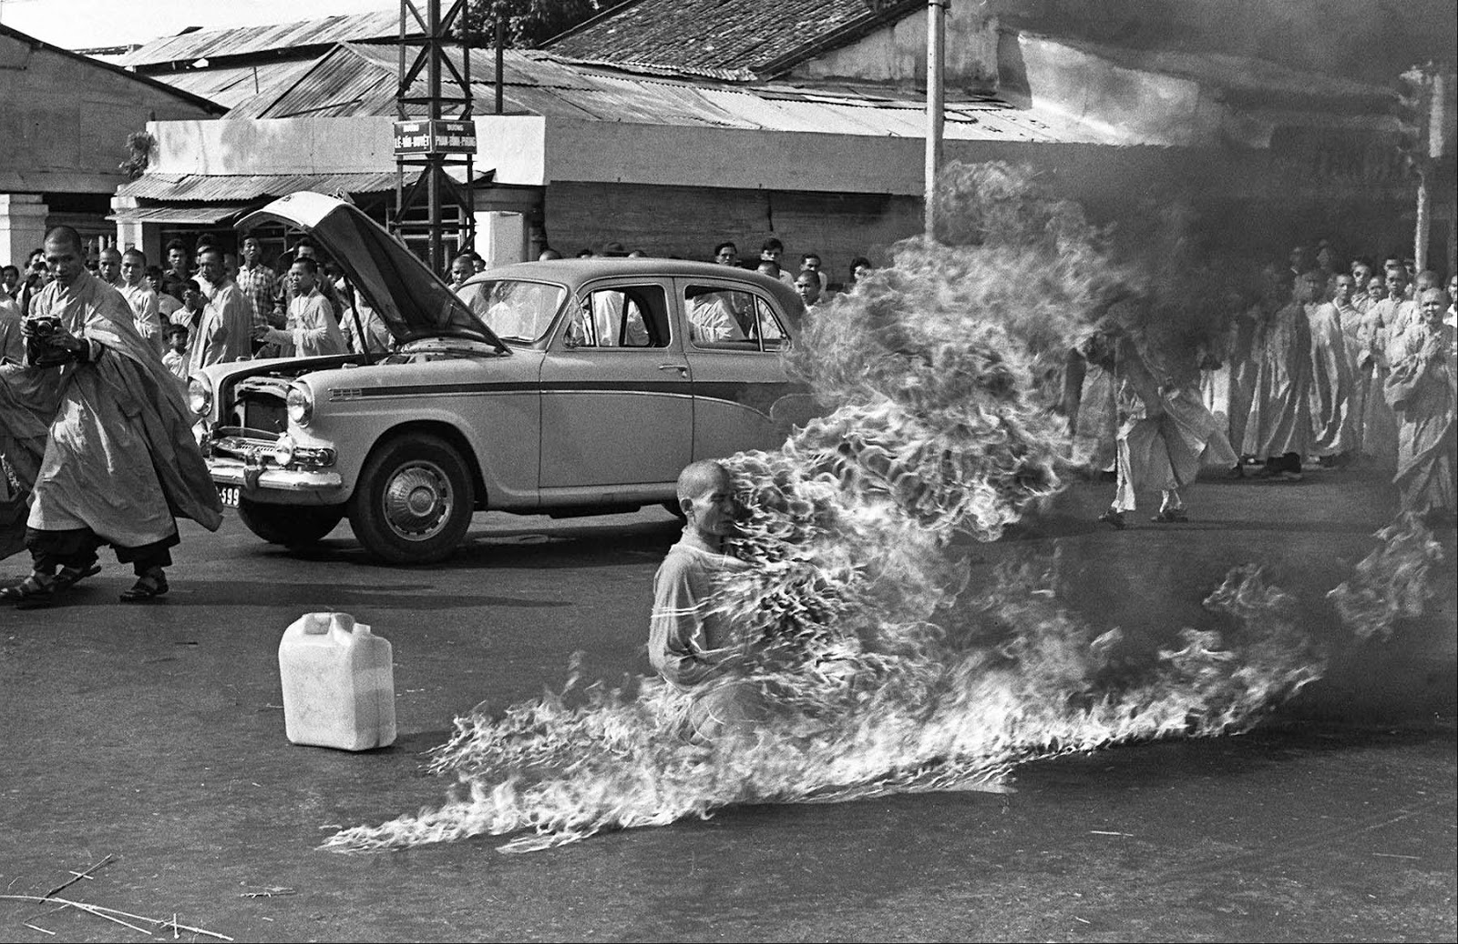

Year 12 History Assessment Programme

In history this year you will be working towards gaining Level Two credits for the National Certificate of Educational Achievement.

The work you do throughout the year will be assessed in two different ways:

- Internal assessment - assignments and activities carried out throughout the year
- External assessment - an exam sat at the end of the year.

The Year 12 history programme is assessed against six achievement standards. Each has a credit weighting. When you gain credit for an achievement standard the credits contribute to your NCEA. You can also gain different grades for each achievement standard: Achievement, Merit, Excellence. The grade you achieve is determined by the quality of your work as measured against national standards.
The Achievement Objectives for this course will see you gain knowledge, skills, and experience to:
- Understand how historical forces and movements have influenced the causes and consequences of events of significance to New Zealanders.
- Understand how people’s interpretations of events that are of significance to New Zealanders differ.

Outlined below are the Level 2 history achievement standards, the credit weighting of each and how they are assessed.

Number | Title | Credits | Assessment
2.1 AS 91229 | Carry out a planned inquiry of an historical event, or place, that is of significance to New Zealanders. | 4 | Internal
2.2 AS 91230 | Examine an historical event, or place, that is of significance to New Zealanders. | 5 | Internal
2.3 AS 91231 | Examine sources of an historical event that is of significance to New Zealanders. | 4 | External
2.4 AS 91232 | Interpret different perspectives of people in an historical event that is of significance to New Zealanders. | 5 | Internal
2.5 AS 91233 | Examine causes and consequences of a significant historical event. | 5 | External
2.6 AS 91234 | Examine how a significant historical event affected New Zealand society. | 5 | External

You will be advised well in advance when each assessment will be carried out and what the assessment policies of the school and this department are.

Assessment Guidelines
Authentication of work will be checked through observation and conferencing during class time allocation. Refer to Student information sheet on "Internal Assessment Procedures" for specific information on internal assessment procedures.

AS 91229 | Carry out an inquiry of an historical event or place that is of significance to New Zealanders
Achievement | Achievement with Merit | Achievement with Excellence
- Carry out an inquiry of an historical event or place that is of significance to New Zealanders. | • Carry out, in-depth, an inquiry of an historical event or place that is of significance to New Zealanders. | • Comprehensively carry out an inquiry of an historical event or place that is of significance to New Zealanders.

AS 91230 | Examine an historical event or place that is of significance to New Zealanders
Achievement | Achievement with Merit | Achievement with Excellence
- Examine an historical event or place that is of significance to New Zealanders. | • Examine, in-depth, an historical event or place that is of significance to New Zealanders. | • Comprehensively examine an historical event or place that is of significance to New Zealanders.

AS 91231 | Examine sources of an historical event that is of significance to New Zealanders
Achievement | Achievement with Merit | Achievement with Excellence
- Examine sources of an historical event that is of significance to New Zealanders. | • Examine in-depth sources of an historical event that is of significance to New Zealanders. | • Comprehensively examine sources of an historical event that is of significance to New Zealanders.

AS 91232 | Interpret different perspectives of people in an historical event that is of significance to New Zealanders
Achievement | Achievement with Merit | Achievement with Excellence
- Interpret different perspectives of people in an historical event that is of significance to New Zealanders. | • Interpret in-depth different perspectives of people in an historical event that is of significance to New Zealanders. | • Comprehensively interpret different perspectives of people in an historical event that is of significance to New Zealanders.

AS 91223 | Examine causes and consequences of a significant historical event
Achievement | Achievement with Merit | Achievement with Excellence
- Examine causes and consequences of a significant historical event. | • Examine in-depth causes and consequences of a significant historical event. | • Comprehensively examine causes and consequences of a significant historical event.

AS 91234 | Examine how a significant historical event affected New Zealand society
Achievement | Achievement with Merit | Achievement with Excellence
- Examine how a significant historical event affected New Zealand society. | • Examine in-depth how a significant historical event affected New Zealand society. | • Comprehensively examine how a significant historical event affected New Zealand society.

The key concepts or big ideas in history

Authentic understanding in history comes from developing a grasp of the key concepts and underlying key historical events, themes, and issues.

Significance
Historians weigh the importance, durability, and relevance of events, themes, and issues in the past and the appropriateness of using the past to provide contemporary lessons; historians debate what is historically significant and how and why the decisions about what is significant change.

Continuity and change
History examines change over time and continuity in times of change. Historians use chronology to place these developments in context. Historians debate what has changed, what has remained the same, and the impact of these changes.

Cause and effect
Historians investigate the reasons for and the results of events in history; they debate the causes of past events and how these events affect people’s lives and communities. Historians study relationships between events to identify pervasive themes, ideas, and movements, such as terrorism, revolution, and migration.

Perspective
There are multiple perspectives on the past (both at the time and subsequently). Interpretations of the past are contested – historians base their arguments on historical evidence and draw from a variety of perspectives.

Others to consider:

- Past and present (refers to the relationship between events in the past and the present day)
- Reliability and usefulness
- Bias and propaganda
- Intent and motivation
- Specific and generalised
- Influence and significance
- Contingency

Topic | Achievement standard | Time of assessment | Reassessment opportunity (if any) | Grade NA/A/ M/E | Initials Grade correct no appeal pending
Event of tragedy | 2.1 AS 91229  Carry out a planned inquiry of an historical event, or place, of significance to New Zealanders. | Term 2 | No
Event of tragedy | 2.2 AS 91230  Examine an historical event, or place, of significance to New Zealanders. | Term 2 | No
Exam | 2.3 AS 91231  Examine sources of an historical event of significance to New Zealanders |  | NA
Vietnam | 2.4 AS 91232  Interpret different perspectives of people in an historical event of significance to New Zealanders. | Term 1 | No
Exam | 2.5 AS 91233  Examine causes and consequences of a significant historical event. | Term 2/ 3 | NA
Exam | 2.6 AS 91234 Examine how a significant historical event affected New Zealand society | Term 2/3 | NA

Year Planner – 12 HIST 2018

TERM 1 | Week 1  29/1 – 2/2 | Week 2  7/2 – 9/2 | Week 3  12/2 – 16/2 | Week 4  19/2 – 23/2 | Week 5  26/2 – 2/3 | Week 6  5/3 –9/3 | Week 7  12/3 – 16/3 | Week 8  19/3 – 23/3 |  | Week 9  26/3 – 30/3 | Week 10  2/4 – 6/4 |  | Week 11  9/4 - 13/4
Context |  | Vietnam |  |  |  |  | Vietnam
Assessment | Waitangi Day |  |  | Swimming sports | Athletics day |  |  |  | Summer Tournament | Easter |  | 2.4 complete
TERM 2 | Week 1  30/4 – 4/4 | Week 2  7/5 – 11/5 | Week 3  14/5 – 18/5 | Week 4  21/5 – 25/5 | Week 5  28/5 – 1/6 | Week 6  5/6 – 8/6 | Week 7  11/6 – 15/6 | Week 8  18/6 – 22/6 |  | Week 9  25/6 – 29/6 | Week 10  2/7 – 6/7
Context | Ireland |  |  |  |  | Event of tragedy
Assessment |  |  |  |  |  | Queen’s birthday |  |  |  |  | 2.1 complete
TERM 3 | Week 1  23/7 – 27/7 | Week 2  30/7 – 3/8 | Week 3  6/8 – 10/8 | Week 4  13/8 – 17/8 | Week 5  20/8 – 24/8 | Week 6  27/8 – 31/8 | Week 7  3/9 – 7/9 | Week 8  10/9 – 14/9 |  | Week 9  17/9 – 21/9 | Week 10  24/9 – 28/9
Context | Event of tragedy |  |  |  |  | Ireland |  |  | Senior Derived Grade  Exams |  | Revision
Assessment |  |  |  |  |  |  | Winter Tournament |  |  |  | 2.2 complete
TERM 4 | Week 1  15/10 – 19/10 | Week 2  23/10 – 26/10 | Week 3  29/10 –2/11 | Week 4  5/11 – 9/11 | Week 5  12/11 – 16/11 | Week 6  19/11 – 23/11 | Week 7  26/11 – 30/11 | Week 8  3/12 – 7/12 |  | Week 9  10/12 –14/12
Context | Revision
Assessment |  | Labour Day

